SCHOOL

Year 12 Trial WACE Examination, 2013

Question/Answer Booklet

MATHEMATICS 3A/3B
SOLUTIONS

Section Two:

Calculator-assumed

Student Number: In figures

In words

Your name

Time allowed for this section
Reading time before commencing work: ten minutes
Working time for this section: one hundred minutes

Materials required/recommended for this section

To be provided by the supervisor
This Question/Answer Booklet
Formula Sheet (retained from Section One)

To be provided by the candidate
Standard items: pens, pencils, pencil sharpener, eraser, correction fluid/tape, ruler, highlighters

Special items: drawing instruments, templates, notes on two unfolded sheets of A4 paper, and up to three calculators satisfying the conditions set by the Curriculum Council for this examination.

Important note to candidates

No other items may be used in this section of the examination. It is your responsibility to ensure that you do not have any unauthorised notes or other items of a non-personal nature in the examination room. If you have any unauthorised material with you, hand it to the supervisor before reading any further.

Structure of this paper

Section | Number of questions available | Number of questions to be answered | Working time (minutes) | Marks available | Percentage of exam
Section One:  Calculator-free | 7 | 7 | 50 | 50 | 33
Section Two:  Calculator-assumed | 12 | 12 | 100 | 100 | 67
 |  |  | Total | 150 | 100

Instructions to candidates

- The rules for the conduct of Western Australian external examinations are detailed in the Year 12 Information Handbook 2013. Sitting this examination implies that you agree to abide by these rules.

- Write your answers in the spaces provided in this Question/Answer Booklet. Spare pages are included at the end of this booklet. They can be used for planning your responses and/or as additional space if required to continue an answer.
- Planning: If you use the spare pages for planning, indicate this clearly at the top of the page.
- Continuing an answer: If you need to use the space to continue an answer, indicate in the original answer space where the answer is continued, i.e. give the page number. Fill in the number of the question(s) that you are continuing to answer at the top of the page.

- Show all your working clearly. Your working should be in sufficient detail to allow your answers to be checked readily and for marks to be awarded for reasoning. Incorrect answers given without supporting reasoning cannot be allocated any marks. For any question or part question worth more than two marks, valid working or justification is required to receive full marks. If you repeat an answer to any question, ensure that you cancel the answer you do not wish to have marked.

- It is recommended that you do not use pencil, except in diagrams.

Section Two: Calculator-assumed (100 Marks)
This section has twelve (12) questions. Answer all questions. Write your answers in the spaces provided.

Working time for this section is 100 minutes.

Question 8 (7 marks)
The number of new accounts created on a recently launched social networking site increase by a factor of three every day. On Day 1, 140 new accounts were created, on Day 2, 420 new accounts were created and so on.

(a) How many new accounts were created on Day 4? (1 mark)

(b) Write a recursive rule for 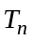, the number of new accounts created on Day . (2 marks)
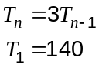

(c) On which day did the number of new accounts created first exceed one million and how many new accounts were created on that day, to the nearest thousand? (2 marks)

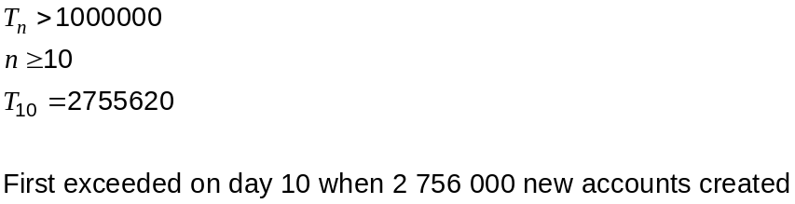

(d) The site earns five cents in advertising revenue for each new account. How much did the site earn in the first seven days? (2 marks)
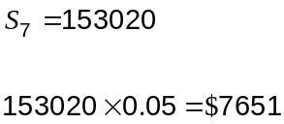

Question 9 (10 marks)
200 tagged catfish were released into a stretch of river. The next day at the same stretch of river, a sample of 140 catfish was caught of which 3 were tagged.

(a) Use this information to calculate an estimate for the number of catfish in the river at this location, to the nearest one hundred fish. (3 marks)
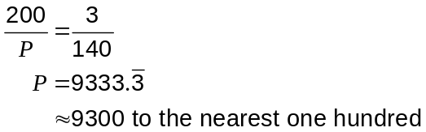

Over the next few days this method of estimating the population of catfish to the nearest one hundred was repeated another ten times at the same location. The population estimates are summarised in the box and whisker plot below.
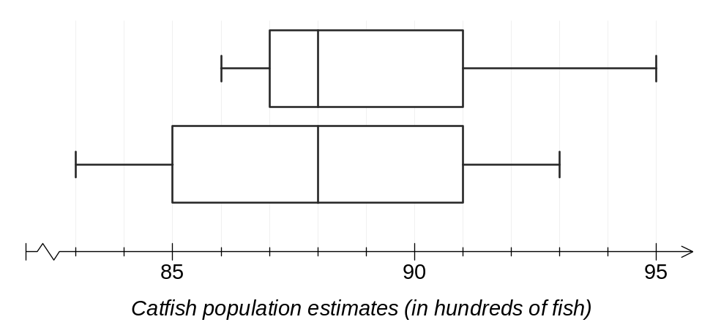
(b) State the median and interquartile range for this set of data. (2 marks)
Median is 88 hundred fish.
IQR is 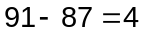 hundred fish.

The same sampling procedure was also carried out at a spot 500 m upriver from the first location, giving rise to a second set of population estimates, in hundreds of fish:

84, 93, 85, 93, 88, 91, 89, 83, 88, 89 and 88

(c) Construct a box and whisker plot for the second set of data on the diagram above.
(3 marks)
Ordered data: 83, 84, 85, 88, 88, 88, 89, 89, 91, 93, 93

Median: 88, Q1 & Q3: 85 & 91 Min & Max: 83 & 93

(d) Which location, the original spot or 500 m upriver, produced the most consistent population estimates? Justify your answer. (2 marks)

The original spot, because both the range and IQR were larger for the stretch 500 m upriver.

Question 10 (7 marks)
The lengths, 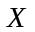, of plastic pipes produced by a machine are normally distributed with a mean of 302 cm and a standard deviation of 1.5 cm.

(a) A pipe is chosen from the production line and has a length of 305 cm.

(i) How many standard deviations from the mean is the length of this pipe? (1 mark)

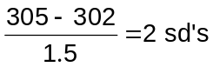

(ii) 95% of the pipes produced by the machine will lie within cm of the mean. Use the 68%, 95%, 99.7% rule to determine the value of . (1 mark)
95% lie within 2 sd's of mean: 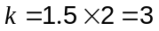

(b) A pipe is chosen at random from the production line. Determine 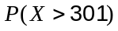. (1 mark)

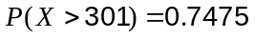

(c) 65 randomly chosen pipes are packed into a crate. Estimate how many of these pipes would be shorter than 300 cm. (2 marks)

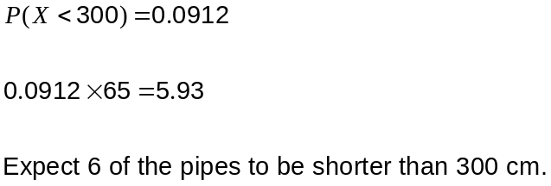

(d) An average of one out of every eight pipes produced by the machine exceeds cm. Determine the value of , rounding your answer to four significant figures. (2 marks)
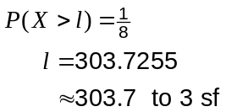

Question 11 (10 marks)
Two subsets, 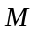 and , belong to a universal set of 200 students. Students belonging to subset have attended a math revision seminar and students belonging to subset have attended a science revision seminar.

It is known that .

(a) Use this information to complete all regions of the Venn diagram below. (3 marks)
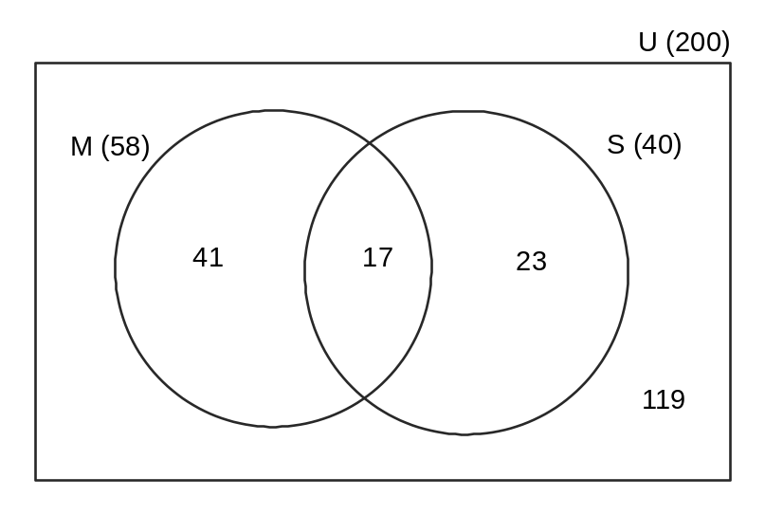
(b) How many students from the group attended just one of the revision seminars? (1 mark)

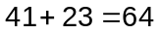

(c) What is the probability that a student selected at random from the group

(i) attended both revision seminars? (1 mark)
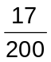

(ii) only attended a math revision seminar? (1 mark)
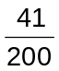

(d) If a student is selected at random from the group, determine

(i) 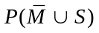 (2 marks)
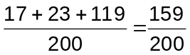

(ii) 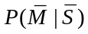 (2 marks)
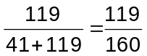

Question 12 (7 marks)
A manager of a building company has split a project into seven jobs that need to be completed. The time, in weeks, that each job requires, is shown in the table below.

Job | A | B | C | D | E | F | G
Time (Weeks) | 12 | 15 | 7 | 8 | 13 | 17 | 2

Some jobs cannot start until other jobs have finished, as instructed below:

- C and D cannot start until A has finished
- F must wait until B has finished
- E must wait until C and D are finished
- G must wait until E and F are finished.

(a) Draw a project network to represent the above information. (3 marks)

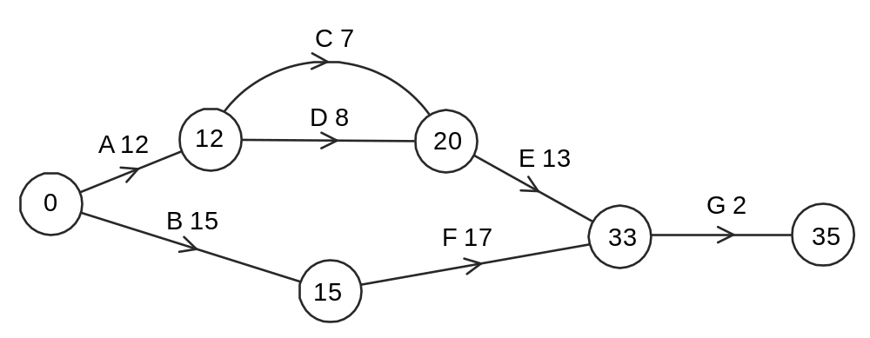

(b) List, in order, the jobs that lie on the critical path and state the minimum completion time for this project. (2 marks)
Critical path is A - D - E - G.

MCT is 35 weeks.

(c) If job B was delayed by two weeks and job C delayed by three weeks, what effect does this have on the critical path and minimum completion time for the project? (2 marks)

Critical path becomes A - C - E - G.

MCT increases to 37 weeks.

Question 13 (7 marks)
Two empty water tanks are to be filled with water.

At 1 pm, a hose delivering a steady 30 litres per minute is placed into tank A and left to run for 20 minutes, at which time it is switched from tank A into tank B.

Ten minutes after the hose is switched, a second hose is placed into tank A, this one delivering a steady 15 litres per minute.

The graph below shows the volume of water in tank B for the first hour.
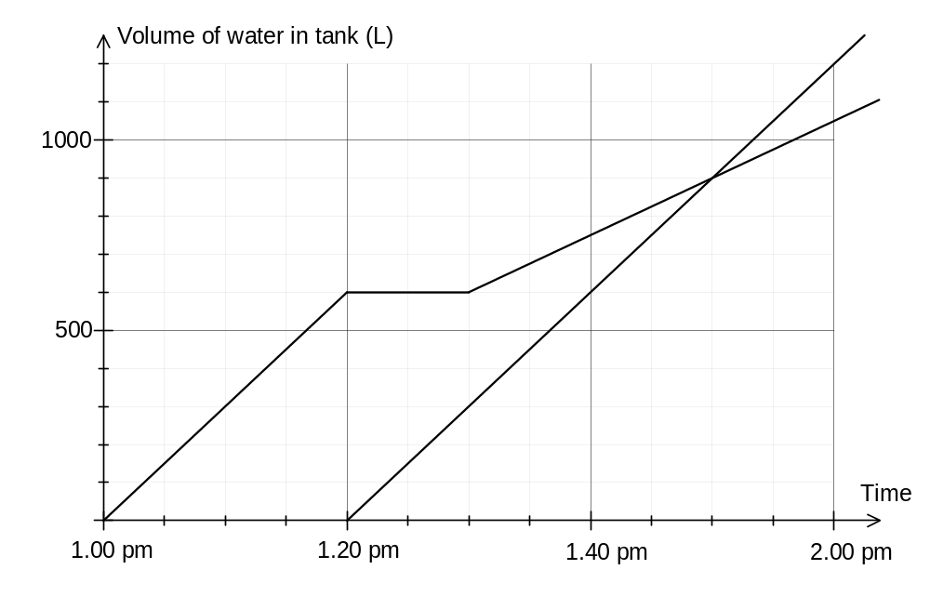
(a) What volume of water was in tank A at 1.20 pm? (1 mark)
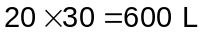

(b) On the axes above, draw the graph for the volume of water in tank A during the first hour.
(2 marks)

(c) Determine the time at which both tanks contained the same volume of water and state what this volume is. (2 marks)
At 1.50 pm both tanks held 900 L of water.

(d) Calculate the rate at which the second hose delivered water, in kilolitres per hour, given that there are 1000 litres in one kilolitre. (2 marks)

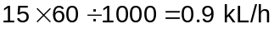

Question 14 (8 marks)
A young person began saving up for a deposit on a home by paying $275 at the start of each month into a First Home Saver account. Account interest and government bonuses combined to grow the balance of the account at a rate of 21% per annum, compounded monthly.

The table below shows the amount in the account at the start of each month, the interest added at the end of the month, the next payment and the balance carried forward to the start of the next month.

Month | Amount at the start of month | Interest for month | Payment | Balance carried forward
 |  | 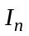 | 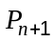 | 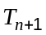
1 | 275.00 | 4.81 | 275.00 | 554.81
2 | 554.81 | 9.71 | 275.00 | 839.52
3 | 839.52 |  | 275.00
4

(a) Calculate the values of entries and in the table above. (2 marks)
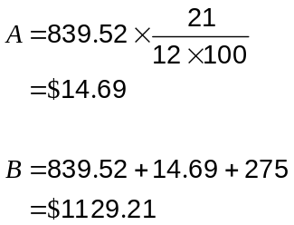

(b) Write a recursive rule to determine the amount in the account at the start of each month.
(3 marks)
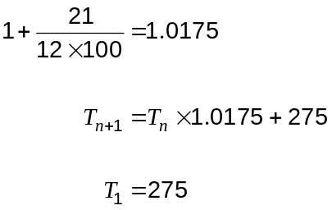

(c) The young person has just made their ninth payment.

(i) How much money is now in their account? (1 mark)
$2655.51

(ii) How much interest has been earned to date? (2 marks)
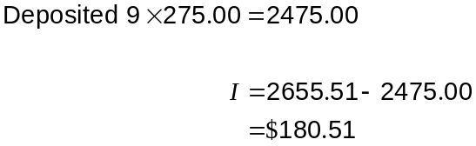

Question 15 (12 marks)
The table and graph below show 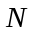, the number of calls per weekday to a new enquiry line, over a three week period, together with five-point moving averages, , and associated residuals, .

 | Week 1 |  |  |  |  | Week 2 |  |  |  |  | Week 3
Day | M | T | W | T | F | M | T | W | T | F | M | T | W | T | F
 | 1 | 2 | 3 | 4 | 5 | 6 | 7 | 8 | 9 | 10 | 11 | 12 | 13 | 14 | 15
 | 48 | 38 | 30 | 38 | 41 | 51 | 39 | 34 | 39 | 44 | 55 | 42 | 39 | 44 | 46
 |  |  | 39.0 | 39.6 | 39.8 | 40.6 | 40.8 | 41.4 | 42.2 | 42.8 | 43.8 | 44.8 | 45.2
 |  |  | -9.0 | -1.6 | 1.2 | 10.4 | -1.8 | -7.4 | -3.2 | 1.2 | 11.2 | -2.8 | -6.2

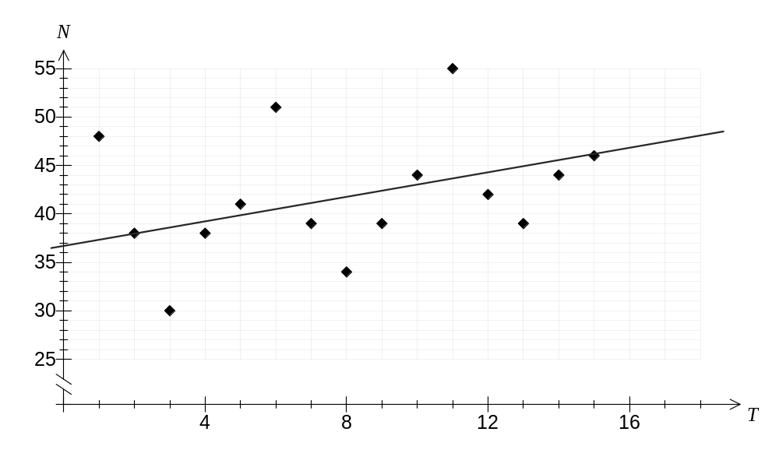

(a) What is noticeable about the number of calls to the enquiry line on Wednesdays? (1 mark)

The number of calls on Wednesdays is always the lowest for each week.

(b) Write down the calculation that was used to determine the five-point moving average for Tuesday of Week 2. (1 mark)
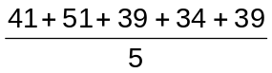

(c) Determine the equation of the linear regression line that can be used to predict the moving average,, from time, . (2 marks)
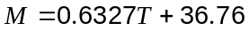

(d) Draw the line of regression calculated in (c) on the graph. (2 marks)

(e) Calculate the seasonal component for the number of calls on Monday. (2 marks)
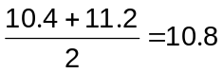

(f) Predict the number of calls to the enquiry centre on Monday of Week 4. (4 marks)
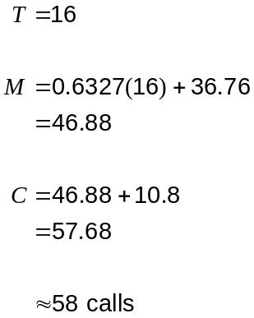

Question 16 (8 marks)
A variety of coffee blends are made by mixing together Brazilian beans that cost $31 per kg with Arabica beans that cost $45 per kg.

(a) Blend X is made by mixing together 8 kg of Brazilian beans with 12 kg of Arabica beans. What is the cost per kg of this blend? (2 marks)

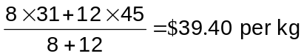

(b) Blend Y is made by mixing together kg of Brazilian beans with 3 kg of Arabica beans. Write an expression for the cost per kg of blend Y and hence determine , given that blend Y costs $32.40 per kg. (2 marks)
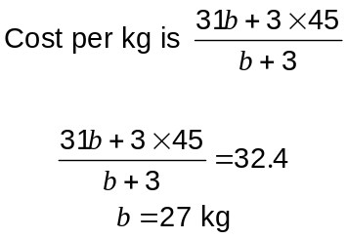

(c) One kilogram of blend Z contains kg of Arabica beans.

(i) Show that the cost of one kg of blend Z is 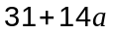. (2 marks)

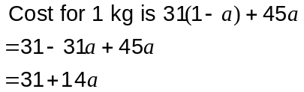

(ii) Blend Z costs $38.70 per kg. Determine the weight of Brazilian beans in a 300 g bag of blend Z. (2 marks)
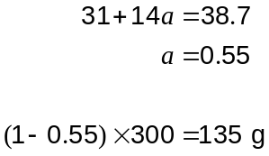

Question 17 (10 marks)
A function is given by 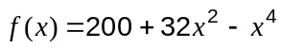 for 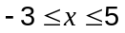.

(a) Use calculus techniques to determine the coordinates of both stationary points of the function for the given domain. (4 marks)
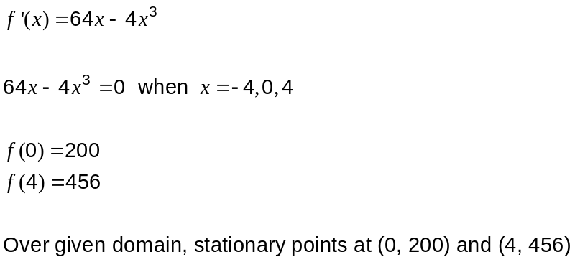

(b) Sketch the graph of  for on the axes below. (4 marks)
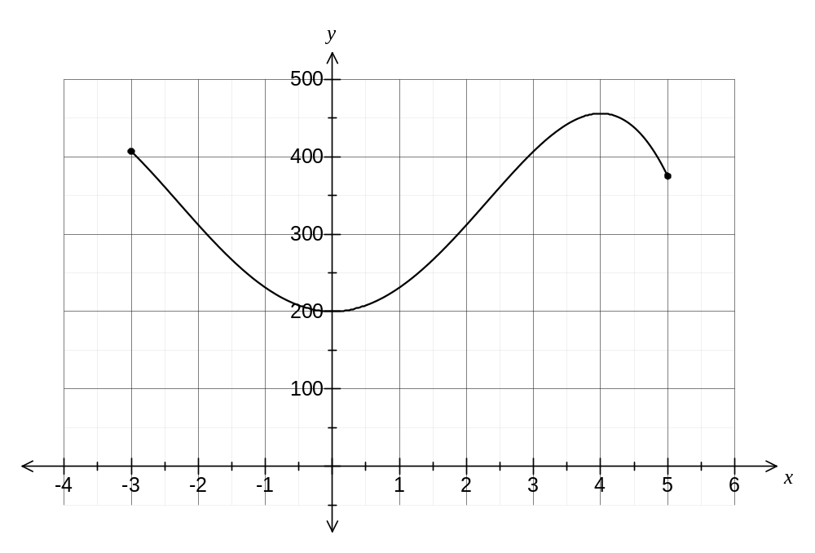
(c) Does the graph above have any inflection points? If so, how many and where(approx.)? (2 marks)
Two Points of inflection at (-2.3, 342.2) and (2.3, 342.2).

Note: No need to give y coordinate
and accept 2 to 2.6
one mark for each point

Question 18 (6 marks)
The pressure, , in an air bubble varies inversely with the volume, , of the bubble.

It is known that 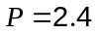kPa when 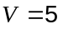 cm³.

(a) Find the value of the constant in the equation 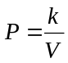. (1 mark)
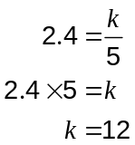

(b) Determine

(i) the value of when 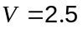 cm³. (1 mark)
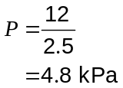

(ii) the value of when 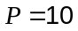 kPa. (1 mark)
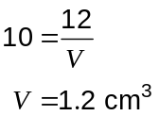

(c) On the axes below, draw a graph to show how varies with . (3 marks)
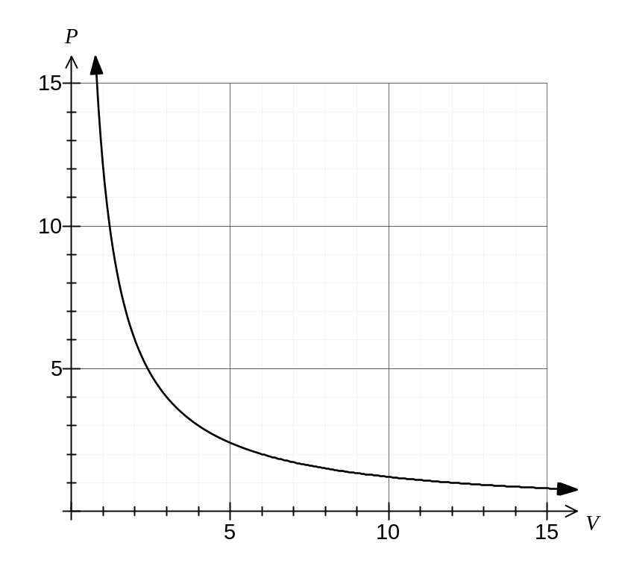

Question 19 (8 marks)
Triangle 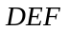 has three sides of lengths 6 cm, 13 cm and 15cm.

(a) Determine the size of the largest angle in triangle . (3 marks)

Largest angle opposite longest side:

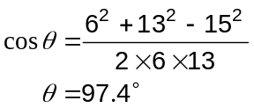

Triangle 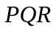 has three sides of lengths of lengths 12 cm, 19 cm and 21 cm.

(b) A student argued that because the three sides of triangle were all 6 cm longer than the corresponding sides of triangle , then the two triangles must be similar.

Explain whether this is a valid argument. (2 marks)

Not a valid argument - the triangles are not similar because the ratio of corresponding side lengths must be the same, not the difference.

Triangle 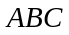 has an area of 350 cm² and is such that the length of 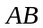 is 5 cm more than the length of 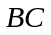 and the size of 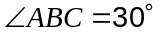.

(c) Determine the length of the side .
(3 marks)
Let length of 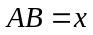. Then

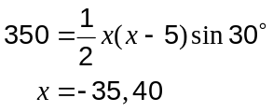

Hence length is 40cm.

This examination paper may be freely copied, or communicated on an intranet, for non-commercial purposes within educational institutes that have purchased the paper from WA Examination Papers provided that WA Examination Papers is acknowledged as the copyright owner. Teachers within purchasing schools may change the paper provided that WA Examination Paper's moral rights are not infringed.

Copying or communication for any other purposes can only be done within the terms of the Copyright Act or with prior written permission of WA Examination papers.

Published by WA Examination Papers
PO Box 445 Claremont WA 6910

